CLASP data user guide

Content:

Acknowledgement statement

Pointing

IRIS co-observation data

Description and graphical examples of data levels

Brief description of data levels available through the VSO (“which data do I want?”)

Lower data levels for all cameras

Higher data levels for slitjaw data

Higher data levels for spectropolarimetric data

Getting data from the VSO

Averaging and estimation of uncertainties

List of references

Point of contact

Acknowledgement statement

All publications and presentations using CLASP data must include the following acknowledgement statement:

We acknowledge the Chromospheric Lyman-Alpha Spectropolarimeter (CLASP) team. The team was an international partnership between NASA Marshall Space Flight Center, National Astronomical Observatory of Japan (NAOJ), Japan Aerospace Exploration Agency (JAXA), Instituto de Astrofísica de Canarias (IAC) and Institut d'Astrophysique Spatiale; additional partners include Astronomical Institute ASCR, Lockheed Martin and University of Oslo. US participation is funded by NASA Low Cost Access to Space (Award Number 12-SHP 12/2-0283). Japanese participation is funded by the basic research program of ISAS/JAXA, internal research funding of NAOJ, and JSPS KAKENHI Grant Numbers 23340052, 24740134, 24340040, and 25220703. Spanish participation is funded by the Ministry of Economy and Competitiveness through project AYA2010-18029 (Solar Magnetism and Astrophysical Spectropolarimetry). French hardware participation was funded by Centre National d’Etudes Spatiales (CNES).

Pointing

CLASP flew on 3 September 2015 and pointed at two different positions on the Sun: at disk center for about 10 seconds for polarization calibration, and at a position near the limb for the rest of the flight. Figure 1 shows the two pointings overplotted on an AIA 304 image during that time.

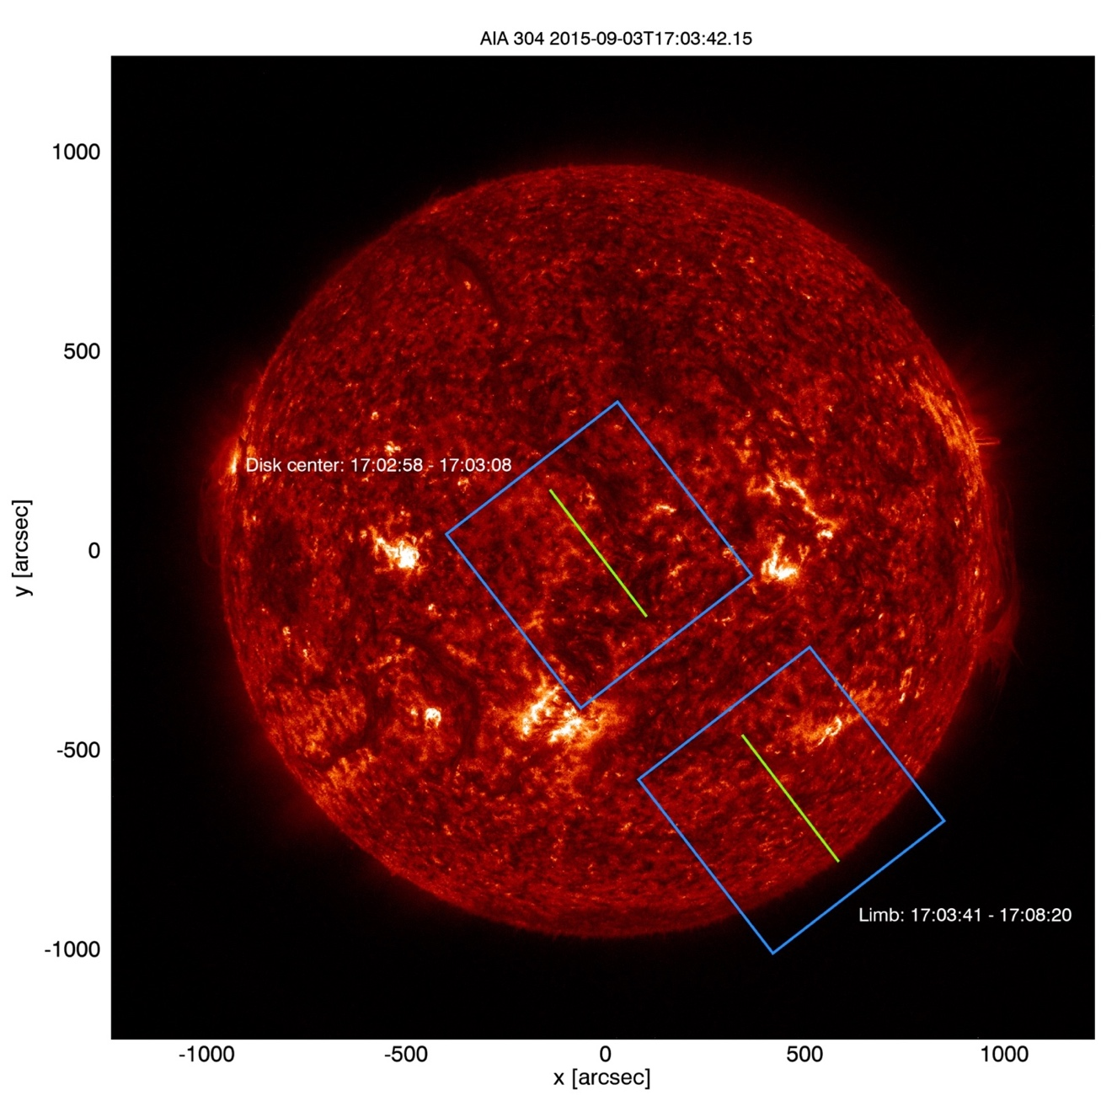
Figure 1: The CLASP pointings at disk center and at the limb. The blue box
outlines the SJ field-of-view, the green line the slit for SP1/SP2.

2.1 IRIS co-observation data

The IRIS co-observation data for CLASP can be found at: https://iris.lmsal.com/search/
OBSID: 4200000019

Description and graphical examples of data levels

CLASP observed in the wavelength region around H Lyman-α (1215.67 Å). The data was taken with three cameras, two cameras for spectropolarimetry (SP1 and SP2) and one slitjaw camera (SJ). The wavelength regions for SP1 and SP2 are different: both observed the Lyman-α line, but only SP2 contains the Si III line (1206.51 Å) in the blue part of the spectrum. Table 1 shows the data levels for each camera, the ones shaded in green are available through the VSO.

 | SJ | SP1 | SP2 | SP  (SP1 and SP2 combined)
Level-0 | X | X | X | -
Level-0.5 | X | X | X | -
Level-1 | X | X | X | X
Level-2 | X | X | X | X

Table 1: Data levels for each camera (green = available through the VSO)

3.1 Brief description of data levels available through the VSO (“which data do I want?”)

Spectropolarimetric data:

Level-0.5: highest cadence data (300 ms), basic correction steps applied, no demodulation, no co-registration, no coordinate information, no water vapor absorption correction.

You probably want this data if... you do not care about polarimetry and need the highest possible cadence for the intensities.

Level-1: lower cadence data (4.8 s), all correction steps applied except for water vapor absorption correction, demodulated, co-registered, coordinate information.

You probably want this data if... you want Stokes parameters and do not care about the
water vapor absorption issue.

Level-2: Level-1 + water vapor absorption correction.

You probably want this data if... you want Stokes parameters and do care about the
water vapor absorption issue. Note that the Level-2
data cannot be used for estimating the photon noise
because the photon noise should be calculated based
on the number of detected photons (electrons).
Slitjaw data:

Level-1: 600 ms cadence, all correction steps applied except for water vapor absorption correction, coordinate information.

You probably want this data if... you want context data.

Level-2: Level-1 + water vapor absorption correction.

You probably want this data if... you want to analyze the slitjaw data.

3.2 Lower data levels for all cameras

Level-0:

- SJ: 600 ms cadence, 728 files
- SP1/SP2: 300 ms cadence, 1405 files each
- unit: DN
- data in primary FITS HDU
- raw data
- timestamp correction
- adding information to the FITS headers:
  - IMG_TYPE: “Dark”, “Moving”, “SunCenter”, “Limb”
  - TELESCOP, INSTRUME, WAVELNTH, etc.

Graphical examples of the data:

Disk center: SJ SP1 SP2
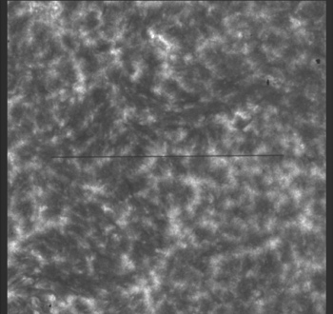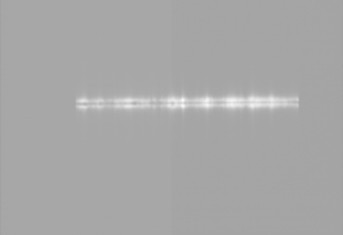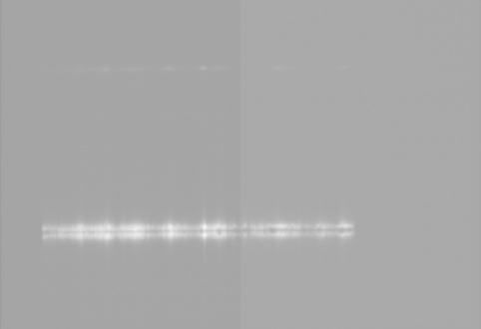

Limb: SJ SP1 SP2
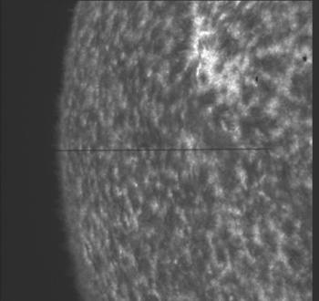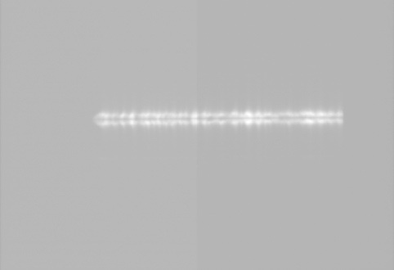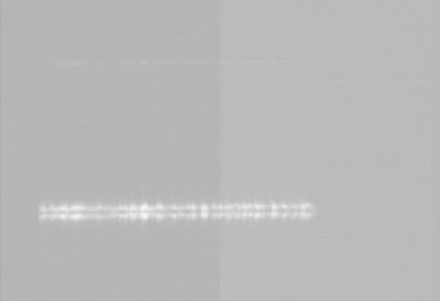
Level-0.5:

- SJ: 600 ms cadence, 484 files (18 disk center, 466 limb),
- SP1/SP2: 300 ms cadence, 954 files each (29 disk center, 925 limb)
- unit: electrons
- data in primary FITS HDU
- correction for:
  - bias
  - dark
  - gain
  - frame transfer image smear
- darks and exposures during slew discarded (IMG_TYPE = “Dark” or “Moving”)
- manually selected images discarded

Graphical examples of the data:

Disk center: SJ SP1 SP2
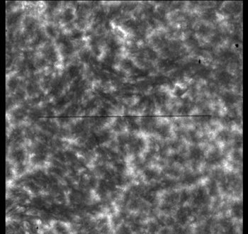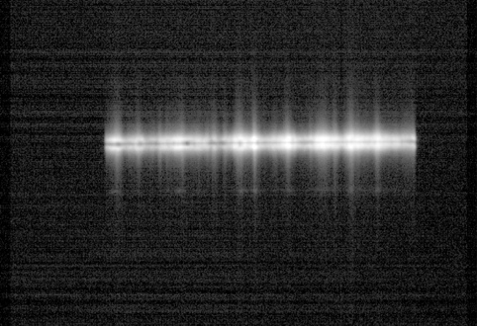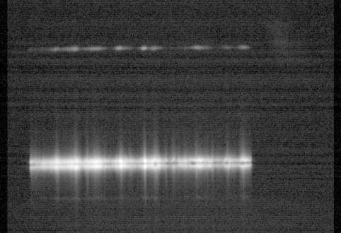

Limb: SJ SP1 SP2
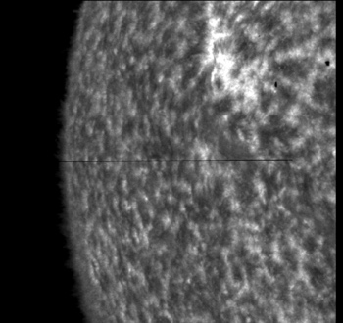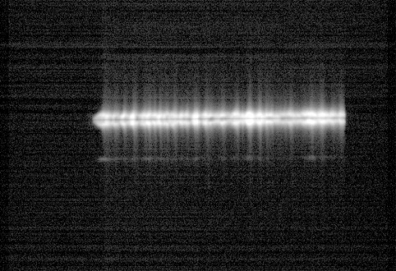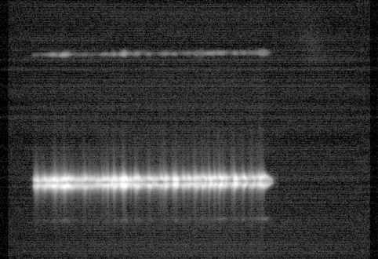

3.3 Higher data levels for slitjaw data

Level-1:

- 600 ms cadence, 484 files (18 disk center, 466 limb)
- unit: electrons
- data in primary FITS HDU
- flatfield correction
- cutting off non-active pixel regions
- image rotation (90° CCW) and horizontal flip
- cross-correlation with AIA 304 data to add coordinates to the FITS headers

Graphical examples of the data:

Disk center Limb
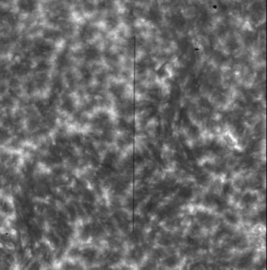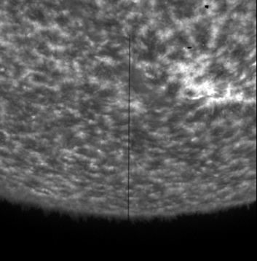

Level-2:

- 600 ms cadence, 484 files (18 disk center, 466 limb)
- unit: electrons
- data in primary FITS HDU
- correction for water vapor absorption issue (only limb data)

Graphical examples of the data:

Disk center Limb
(same as Level-1)
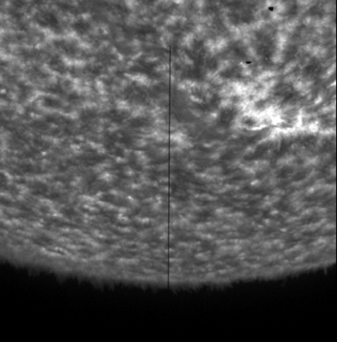

3.4 Higher data levels for spectropolarimetric data

Level-1:

- 4.8 s cadence, 58 files each for SP1/SP2/SP (1 disk center, 57 limb)
- unit: electrons
- Stokes I/Q/U in FITS extension 1/2/3
- correction for:
  - straylight
  - horizontal fringes
- polarization demodulation
- cutting off non-active pixel regions
- SP1: image rotation (90° CCW)
- SP2: image rotation (90° CW) and horizontal flip
- affine transformation:
  - shift (co-registration, middle of slit = middle of data)
  - rotation (wavelength axis parallel to x-axis, slit axis parallel to y-axis)
- combining SP1 and SP2 to SP (only overlapping wavelength range around Lyman-α)
  - compensation for (slightly) different SP2 spatial scale
  - process of combining SP1 and SP2 is described below

Graphical examples of the data:

Disk center: SP1 SP2
I Q U I Q U
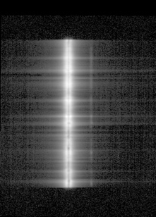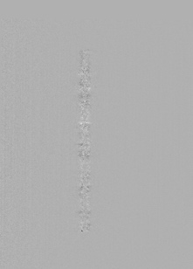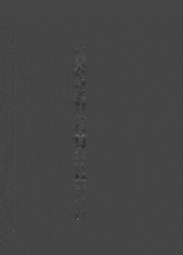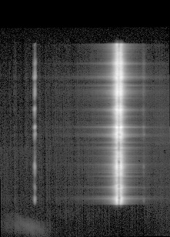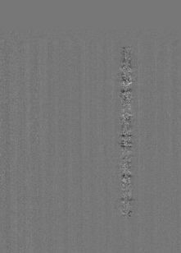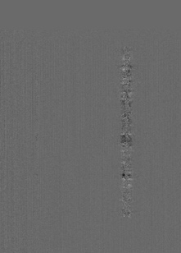

SP (SP1 and SP2 combined)
I Q U
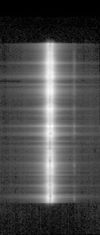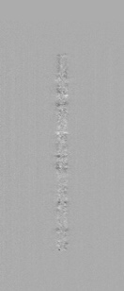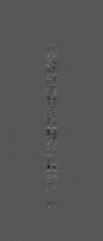

Limb: SP1 SP2
I Q U I Q U
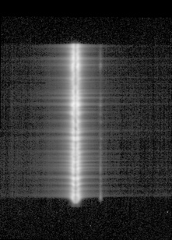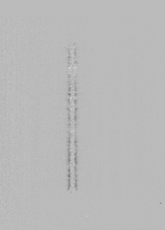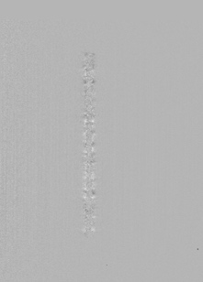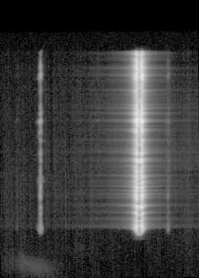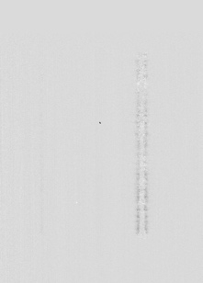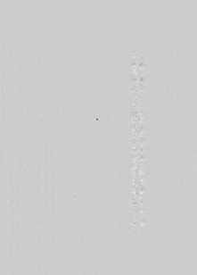

SP (SP1 and SP2 combined)
I Q U
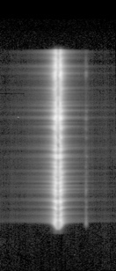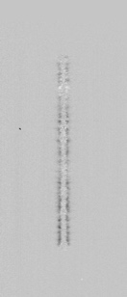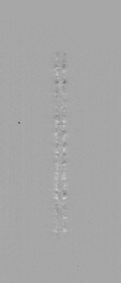

How SP1 and SP2 are combined (description is for Stokes Q, same for Stokes U):

- Derive the fractional polarization at each spatial and wavelength pixel at each PMU rotation in each channel:
$q_{\text{SP1}}=\frac{K_{1}Q(x,λ,t)}{K_{1}I(x,λ,t)}=\frac{Q_{\text{SP1}}(x,λ,t)}{I_{\text{SP1}}(x,λ,t)}$ $q_{\text{SP2}}=\frac{K_{2}Q(x,λ,t)}{K_{2}I(x,λ,t)}=\frac{Q_{\text{SP2}}(x,λ,t)}{I_{\text{SP2}}(x,λ,t)}$
where t is the PMU rotation number and $K_{1}$ and $K_{2}$ are the throughputs in SP1 and SP2
- Take the average of the fractional polarization between the two channels: $q_{\text{SP}}=\left(q_{\text{SP1}}(x,λ,t)+q_{\text{SP2}}(x,λ,t)\right)/2$
Note: the averaged quantity $q_{\text{SP}}$ is the fractional polarization without any uncertainty
in throughput. This process also cancels out I $→$ Q/U crosstalk.
$q_{\text{SP}}=\left(\frac{K_{1}Q(x,λ,t)}{K_{1}I(x,λ,t)}+\frac{K_{2}Q(x,λ,t)}{K_{2}I(x,λ,t)}\right)/2=\frac{Q(x,λ,t)}{I(x,λ,t)}$
- Multiply the averaged fractional polarization with the sum of the SP1 & SP2 intensities:
$$Q_{\text{SP}}(x,λ,t)=q_{\text{SP}}(x,λ,t)∙\left(I_{\text{SP1}}(x,λ,t)+I_{\text{SP2}}(x,λ,t)\right)=q_{\text{SP}}(x,λ,t)∙I_{\text{SP}}(x,λ,t)$$
- The final outputs are: $I_{\text{SP}}\left(x,λ,t\right), Q_{\text{SP}}\left(x,λ,t\right), U_{\text{SP}}(x,λ,t)$
Advantage of this procedure: $I_{\text{SP}}\left(x,λ,t\right)$ directly provides the total number of $e^{-}$ collected by the two channels.

Level-2:

- 4.8 s cadence, 58 files each for SP1/SP2/SP (1 disk center, 57 limb)
- unit: electrons
- Stokes I/Q/U in FITS extension 1/2/3
- correction for water vapor absorption issue (only limb data)
Graphical examples of the data:

Disk center: SP1 SP2
I Q U I Q U

SP (SP1 and SP2 combined)
I Q U

Limb: SP1 SP2
I Q U I Q U
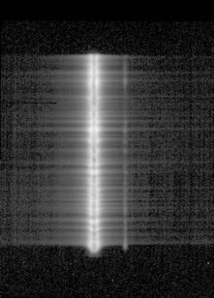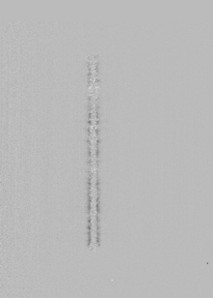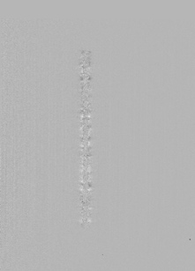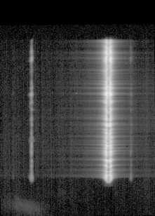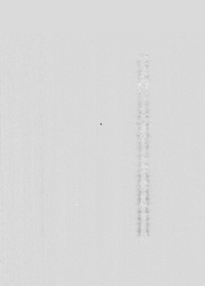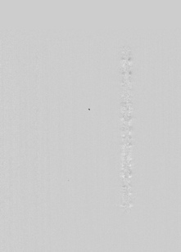

SP (SP1 and SP2 combined)
I Q U

3.5 Getting data from the VSO

The CLASP data is available here: https://msfc.virtualsolar.org/CLASP1/
It is organized in zip files that contain all data levels for each instrument.

Averaging and estimation of uncertainties

Averaging

In order to achieve high S/N, it is highly recommended to temporally average/integrate the Stokes signals as follows:
- $\overline{q}=\frac{Q_{SP}\left(x,λ,t_{1}\right)+Q_{SP}\left(x,λ,t_{2}\right)+Q_{SP}\left(x,λ,t_{3}\right)+Q_{SP}\left(x,λ,t_{4}\right)+ ⋯}{I_{SP}\left(x,λ,t_{1}\right)+I_{SP}\left(x,λ,t_{2}\right)+I_{SP}\left(x,λ,t_{3}\right)+I_{SP}\left(x,λ,t_{4}\right)+ ⋯}$
- $\overline{u}=\frac{U_{SP}\left(x,λ,t_{1}\right)+U_{SP}\left(x,λ,t_{2}\right)+U_{SP}\left(x,λ,t_{3}\right)+U_{SP}\left(x,λ,t_{4}\right)+ ⋯}{I_{SP}\left(x,λ,t_{1}\right)+I_{SP}\left(x,λ,t_{2}\right)+I_{SP}\left(x,λ,t_{3}\right)+I_{SP}\left(x,λ,t_{4}\right)+ ⋯}$
Take the fraction after summation. Spatial and wavelength averaging can be done similarly.

Uncertainties

The main source of uncertainties are the photon noise and readout noise (Ishikawa et al. 2014), and can be estimated as follows:
- $∆q=\sqrt{{{Δq}_{photon}}^{2}+{Δq_{CCD}}^{2}}$
- $Δq_{photon}=Δu_{photon}=\frac{1}{a\sqrt{N}}$
- $Δq_{CCD}=Δu_{CCD}=\frac{\sqrt{n}σ_{s}}{aN}$

a = 0.64 : modulation coefficient
$N=$ $I_{SP}\left(x,λ,t_{1}\right)+I_{SP}\left(x,λ,t_{2}\right)+I_{SP}\left(x,λ,t_{3}\right)+I_{SP}\left(x,λ,t_{4}\right)+⋯$ $I_{SP}\left(x,λ,t_{M}\right)$ : total number of e⁻
$n=2×16×n_{M}$ : total number of accumulated exposures. $I_{SP}\left(x,λ,t_{i}\right)$ consists of data from two
channels and 16 exposures
$n_{M}$: Number of summations (spatial/temporal/wavelength)
$σ_{s}=6{\text{e}}^{-1}$ (read-out noise, Champey et al. 2014, 2015)
Note that the uncertainties caused by the read-out noise are usually negligible compared to the photon noise.

List of references

Project Overview

- Kano, R., et al. 2012, Proc. SPIE, 8443, 84434F
- Kobayashi, K., et al. 2012, in ASP Conf. Ser. 456, 233

Instrument papers

Optical design and performance overview

- Narukage, N., et al. 2015, ApOpt, 54, 2080 (optical design of spectropolarimeter)
- Kubo, M., et al. 2016, ApJ, 832, 141 (slitjaw overview)
- Narukage, N., et al. 2017, SoPh, 292, 40 (coating)
- Giono, G., et al. 2016, Proceedings of the SPIE, Vol. 9905 (alignment and performance verification of spectropolarimeter)

Polarimetry (in addition to the list above)

- Ishikawa, R., et al. 2013, ApOpt, 52, 8205 (waveplate)
- Ishikawa, R., et al. 2014, SoPh, 289, 4727 (strategy for high precision polarimetry and noise estimates)
- Ishikawa, S., et al. 2015, SoPh, 290, 3081 (polarization modulation unit)
- Giono, G., et al. 2016, SoPh, 291, 3831 (pre-flight polarization calibration)
- Giono, G., et al. 2017, SoPh, 292, 57 (in-flight polarization calibration)

Cameras

- Champey, P., et al. 2014, Proceedings of the SPIE, Vol. 9144
- Champey, P., et al. 2015, Proceedings of the SPIE, Vol. 9601

Science papers

- Kano, R., et al. 2017, ApJ, Vol. 839, L10 (CLASP first result paper: detection of scattering polarization)
- Trujillo Bueno, J., et al. 2018, ApJL, Vol. 866, L15 (constraints on the magnetization and geometrical complexity)
- Alsina Ballester, E., et al. 2023, Vol. 947, 71 (interpretation of scattering polarization observed by the slitjaw)
- Ishikawa, R., et al. 2017, ApJ, Vol. 841, 311 (Si III scattering polarization and detection of Hanle effect)
- Schmit, D., et al. 2017, ApJ, Vol. 847, 141 (comparison of Lya and Mg II intensity spectra)
- Ishikawa, S., et al. 2017, ApJ, Vol. 846, 127 (rapid time variation in Lyman-α)
- Yoshida, M., et al. 2019, ApJ, Vol. 887, 2 (Spicule in Lyman-α)

Reviews

- Trujillo Bueno, J. and del Pino Alemán, T. 2022, Annual Review of A&A, Vol. 60, 415-453

Point of contact

Amy Winebarger
NASA Marshall Space Flight Center ST13
Huntsville, AL 35812
USA
amy.winebarger [at] nasa.gov

During the CLASP flight, water vapor spread in the optical section, probably caused by ice accumulating on the camera cold blocks. This created an absorption issue, i.e. in all data < Level-2, the intensities drop over time.

