CLASP2 data user guide

Content:

Acknowledgement statement

Pointing

IRIS co-observation data

Description and graphical examples of data levels

Brief description of data levels available through the VSO (“which data do I want?”)

Lower data levels for all cameras

Higher data levels for slitjaw data

Higher data levels for spectropolarimetric dat

Getting data from the VSO

Averaging and estimation of uncertainties

List of references

Point of contact

Acknowledgement statement

All publications and presentations using CLASP2 data must include the following acknowledgement statement:

CLASP2 is an international partnership between NASA/MSFC, NAOJ, JAXA, IAC, and IAS; additional partners include ASCR, IRSOL, LMSAL, and the University of Oslo. The CLASP2 research was funded by ISAS/JAXA as a Small Mission-of-Opportunity Program, by JSPS KAKENHI Grant numbers JP25220703 and 16H03963, 2015 ISAS Grant for Promoting International Mission Collaboration, 2016 NAOJ Grant for Development Collaboration, NASA Award 16-HTIDS16_2-0027, and Spanish participation through ERC Advanced Grant agreement 742265; and French hardware participation was funded by CNES funds CLASP2-13616A and 13617A.

Pointing

CLASP2 flew on 11 April 2019 and pointed at three different positions on the Sun: at disk center for about 15 seconds for polarization calibration, at a plage position for about 2 min 26 sec, and near the limb for the rest of the flight. Figure 1 shows the three pointings overplotted on an AIA 304 image during that time.

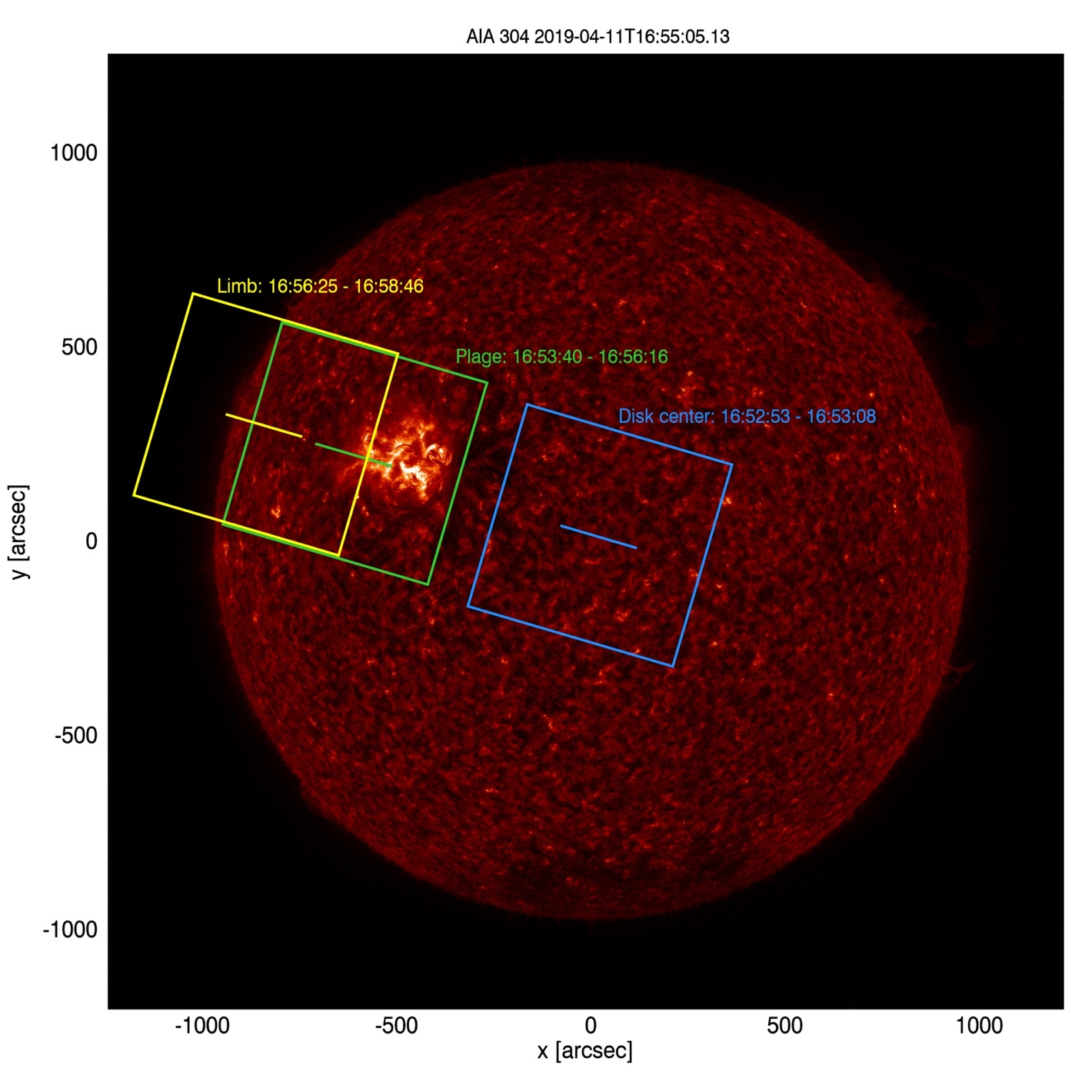
Figure 1: The CLASP2 pointings at disk center, plage, and near the limb.
Times are in UTC.
2.1 IRIS co-observation data

The IRIS co-observation data for CLASP2 can be found at: https://iris.lmsal.com/search/
OBSID: 3683603440
Note that there is also context data available at different times. Search for “CLASP-2” in the “DESC” box.

Description and graphical examples of data levels

CLASP2 observed in the wavelength region around Mg II h & k. The data was taken with three cameras, two cameras for spectropolarimetry (SP1 and SP2) and one slitjaw camera (SJ).
Table 1 shows the data levels for each camera, the ones shaded in green are available through the VSO.

 | SJ | SP1 | SP2 | SP  (SP1 and SP2 combined)
Level-0 | X | X | X | -
Level-0.5 | X | X | X | -
Level-1 | X | X | X | X

Table 1: Data levels for each camera (green = available through the VSO)

3.1 Brief description of data levels available through the VSO (“which data do I want?”)

Spectropolarimetric data:

Level-0.5: highest cadence data (200 ms), basic correction steps applied, no demodulation,
no co-registration, no coordinate information.

You probably want this data if... you do not care about polarimetry or coordinates and need the highest possible cadence for the intensities.

Level-1: lower cadence data (3.2 s), all correction steps applied, demodulated,
co-registered, coordinate information.

You probably want this data if... you want Stokes parameters and/or coordinates.

Slitjaw data:

Level-1: 600 ms cadence, all correction steps applied.
3.2 Lower data levels for all cameras

Level-0:

- SJ: 600 ms cadence
- SP1/SP2: 200 ms cadence
- unit: DN
- data in primary FITS HDU
- raw data
- timestamp correction
- adding information to the FITS headers:
  - TARGET: “Dark”, “Moving”, “SunCenter”, “Plage”, “Limb”
  - TELESCOP, INSTRUME, WAVELNTH, etc.

Graphical examples of the data:

Disk center: SJ SP1 SP2
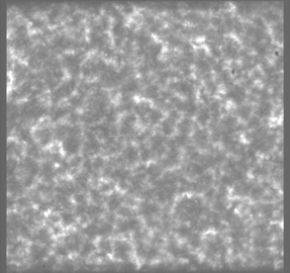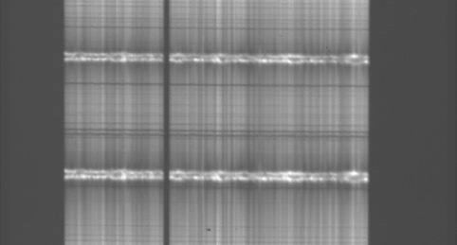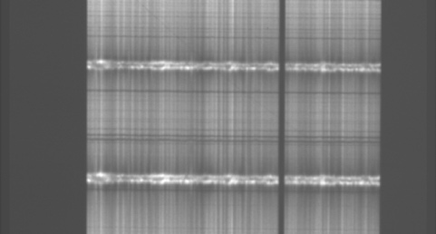

Plage: SJ SP1 SP2
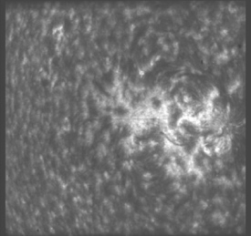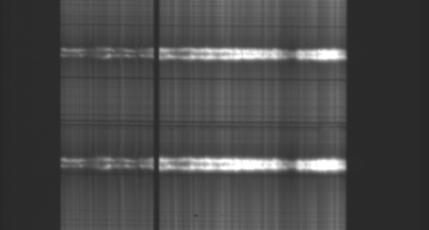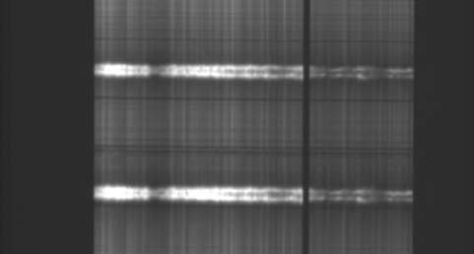

Limb: SJ SP1 SP2
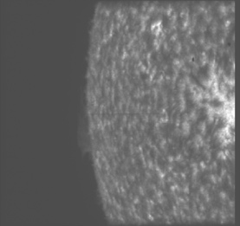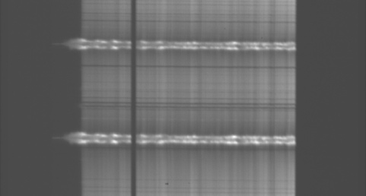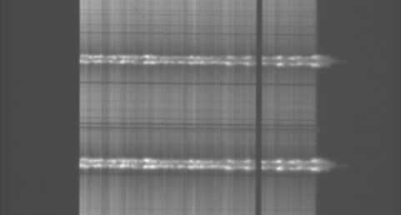
Note: The vertical black line in the SP1/SP2 data is caused by dust obscuring part of the slit.

Level-0.5:

- SJ: 600 ms cadence
- SP1/SP2: 200 ms cadence
- unit: electrons
- data in primary FITS HDU
- correction for:
  - bias
  - dark
  - gain
  - frame transfer image smear
- darks and exposures during slew discarded (TARGET = “Dark” or “Moving”)
- manually selected images discarded

Graphical examples of the data:

Disk center: SJ SP1 SP2
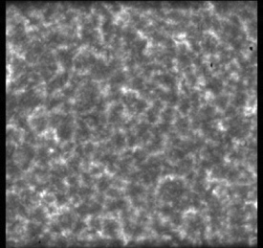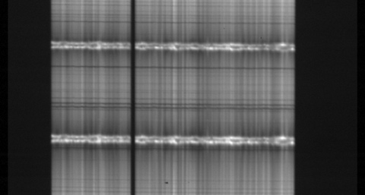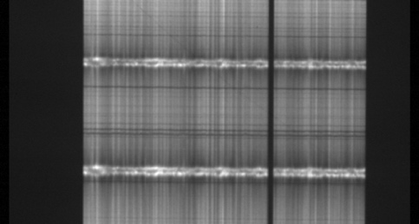

Plage: SJ SP1 SP2
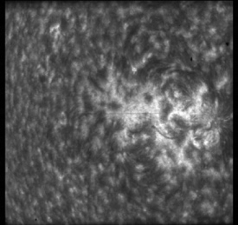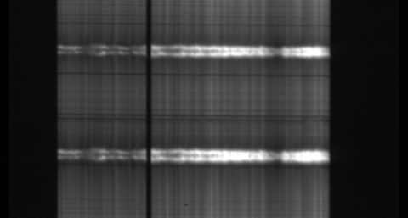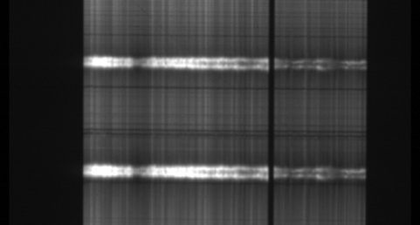

Limb: SJ SP1 SP2
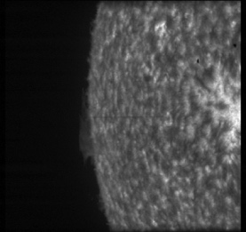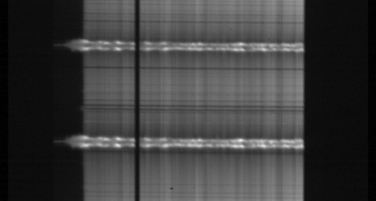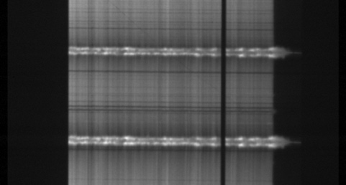

3.3 Higher data levels for slitjaw data

Level-1:

- 600 ms cadence
- unit: electrons
- data in primary FITS HDU
- flatfield correction
- cutting off non-active pixel regions
- image rotation (90° CW) and horizontal flip
- cross-correlation with AIA 304 data to add coordinates to the FITS headers

Graphical examples of the data:

Disk center Plage Limb
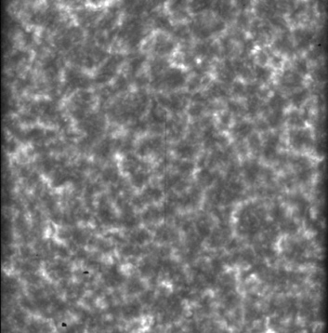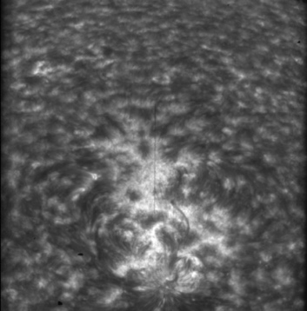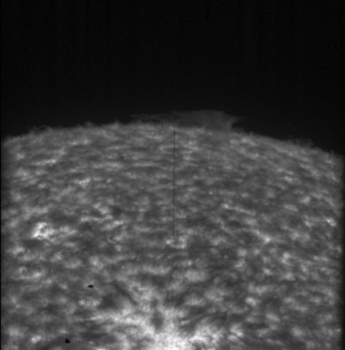

3.4 Higher data levels for spectropolarimetric data

Level-1:

- 3.2 s cadence
- unit: electrons
- Stokes I/Q/U/V in FITS extension 1/2/3/4
- polarization demodulation
- cutting off non-active pixel regions
- SP1: image rotation (90° CW)
- SP2: image rotation (90° CCW) and horizontal flip
- affine transformation:
  - shift (co-registration, slit drift compensation)
  - rotation (wavelength axis parallel to x-axis, slit axis parallel to y-axis)
- combining SP1 and SP2 to SP
  - compensation for (slightly) different SP2 spatial scale
  - process of combining SP1 and SP2 is described below
Graphical examples of the data:

Disk center: SP1 SP2
I Q U V I Q U V
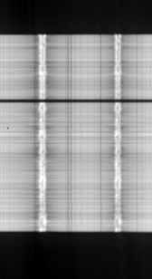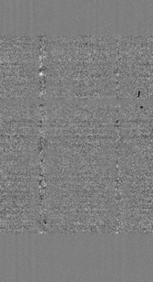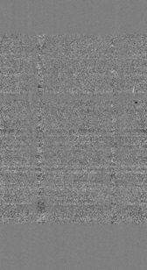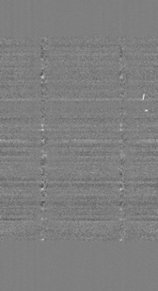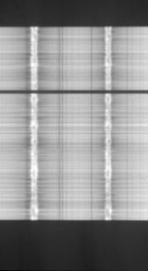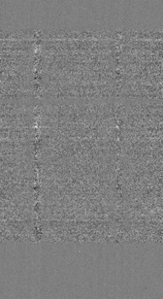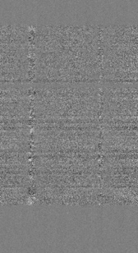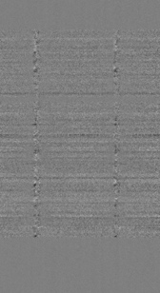

SP (SP1 and SP2 combined)
I Q U V
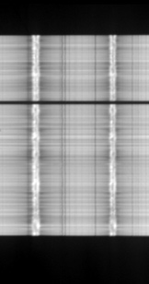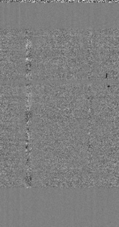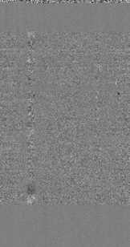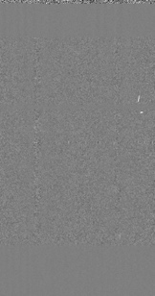

Plage: SP1 SP2
I Q U V I Q U V
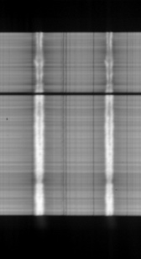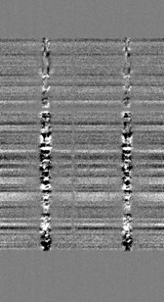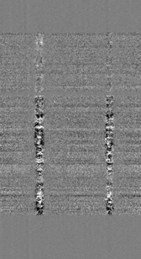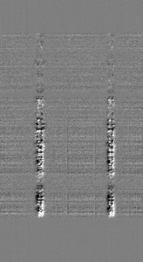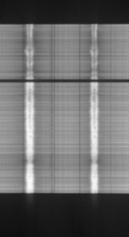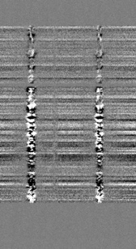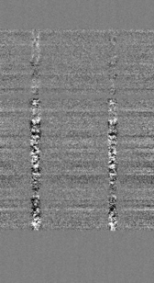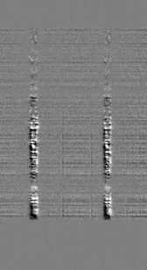

SP (SP1 and SP2 combined)
I Q U V
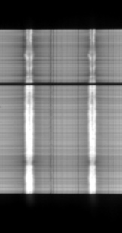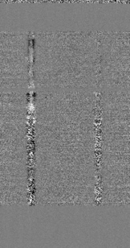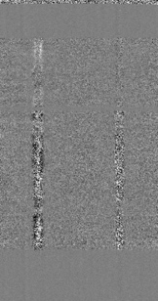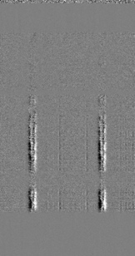

Limb: SP1 SP2
I Q U V I Q U V
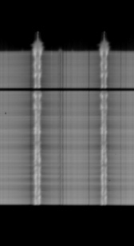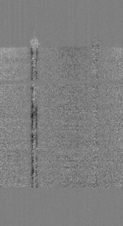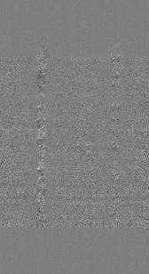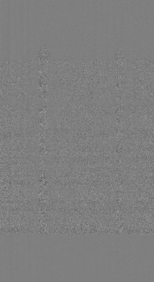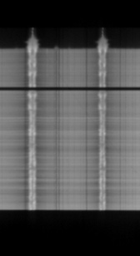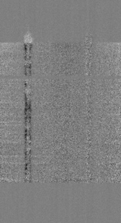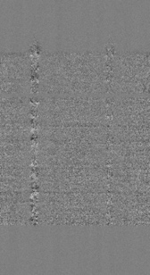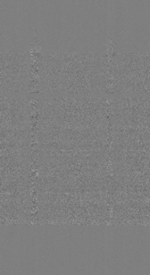

SP (SP1 and SP2 combined)
I Q U V
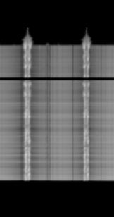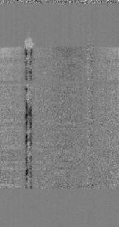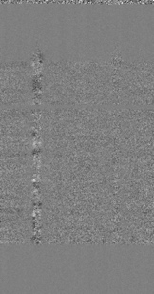

How SP1 and SP2 are combined (description is for Stokes Q, same for Stokes U and V):

- Derive the fractional polarization at each spatial and wavelength pixel at each PMU rotation in each channel:
$q_{\text{SP1}}=\frac{K_{1}Q(x,λ,t)}{K_{1}I(x,λ,t)}=\frac{Q_{\text{SP1}}(x,λ,t)}{I_{\text{SP1}}(x,λ,t)}$ $q_{\text{SP2}}=\frac{K_{2}Q(x,λ,t)}{K_{2}I(x,λ,t)}=\frac{Q_{\text{SP2}}(x,λ,t)}{I_{\text{SP2}}(x,λ,t)}$
where t is the PMU rotation number and $K_{1}$ and $K_{2}$ are the throughputs in SP1 and SP2
- Take the average of the fractional polarization between the two channels: $q_{\text{SP}}=\left(q_{\text{SP1}}(x,λ,t)+q_{\text{SP2}}(x,λ,t)\right)/2$
Note: the averaged quantity $q_{\text{SP}}$ is the fractional polarization without any uncertainty
in throughput. This process also cancels out I $→$ Q/U crosstalk.
$q_{\text{SP}}=\left(\frac{K_{1}Q(x,λ,t)}{K_{1}I(x,λ,t)}+\frac{K_{2}Q(x,λ,t)}{K_{2}I(x,λ,t)}\right)/2=\frac{Q(x,λ,t)}{I(x,λ,t)}$
- Multiply the averaged fractional polarization with the sum of the SP1 & SP2 intensities:
$$Q_{\text{SP}}(x,λ,t)=q_{\text{SP}}(x,λ,t)∙\left(I_{\text{SP1}}(x,λ,t)+I_{\text{SP2}}(x,λ,t)\right)=q_{\text{SP}}(x,λ,t)∙I_{\text{SP}}(x,λ,t)$$
- The final outputs are: $I_{\text{SP}}\left(x,λ,t\right), Q_{\text{SP}}\left(x,λ,t\right), U_{\text{SP}}\left(x,λ,t\right), V_{\text{SP}}(x,λ,t)$
Advantage of this procedure: $I_{\text{SP}}\left(x,λ,t\right)$ directly provides the total number of $e^{-}$ collected by the two channels.

3.5 Getting data from the VSO

The CLASP2 data is available here: https://msfc.virtualsolar.org/CLASP2/
It is organized in zip files that contain all data levels for each instrument.

Averaging and estimation of uncertainties

Averaging

In order to achieve high S/N, it is highly recommended to temporally average/integrate the Stokes signals as follows:
- $\overline{q}=\frac{Q_{SP}\left(x,λ,t_{1}\right)+Q_{SP}\left(x,λ,t_{2}\right)+Q_{SP}\left(x,λ,t_{3}\right)+Q_{SP}\left(x,λ,t_{4}\right)+ ⋯}{I_{SP}\left(x,λ,t_{1}\right)+I_{SP}\left(x,λ,t_{2}\right)+I_{SP}\left(x,λ,t_{3}\right)+I_{SP}\left(x,λ,t_{4}\right)+ ⋯}$
- $\overline{u}=\frac{U_{SP}\left(x,λ,t_{1}\right)+U_{SP}\left(x,λ,t_{2}\right)+U_{SP}\left(x,λ,t_{3}\right)+U_{SP}\left(x,λ,t_{4}\right)+ ⋯}{I_{SP}\left(x,λ,t_{1}\right)+I_{SP}\left(x,λ,t_{2}\right)+I_{SP}\left(x,λ,t_{3}\right)+I_{SP}\left(x,λ,t_{4}\right)+ ⋯}$
- $\overline{v}=\frac{V_{SP}\left(x,λ,t_{1}\right)+V_{SP}\left(x,λ,t_{2}\right)+V_{SP}\left(x,λ,t_{3}\right)+V_{SP}\left(x,λ,t_{4}\right)+ ⋯}{I_{SP}\left(x,λ,t_{1}\right)+I_{SP}\left(x,λ,t_{2}\right)+I_{SP}\left(x,λ,t_{3}\right)+I_{SP}\left(x,λ,t_{4}\right)+ ⋯}$
Take the fraction after summation. Spatial and wavelength averaging can be done similarly.

Uncertainties

The main source of uncertainties are the photon noise and readout noise (Ishikawa et al. 2014), and can be estimated as follows:
- $∆q=\sqrt{{{Δq}_{photon}}^{2}+{Δq_{CCD}}^{2}}$, $∆u=\sqrt{{{Δu}_{photon}}^{2}+{Δu_{CCD}}^{2}}$, $∆v=\sqrt{{{Δv}_{photon}}^{2}+{Δv_{CCD}}^{2}}$
- $Δq_{photon}=Δu_{photon}=\frac{1}{a\sqrt{N}}$, $Δv_{photon}=\frac{1}{c\sqrt{N}}$
- $Δq_{CCD}=Δu_{CCD}=\frac{\sqrt{n}σ_{s}}{aN}$, $Δv_{CCD}=\frac{\sqrt{n}σ_{s}}{cN}$
$a=(1-\cos{{(234}^{°})})/π$, $c=-2\sin{{(234}^{°})}/π$: modulation coefficient (Song et al. 2022)
$N=$ $I_{SP}\left(x,λ,t_{1}\right)+I_{SP}\left(x,λ,t_{2}\right)+I_{SP}\left(x,λ,t_{3}\right)+I_{SP}\left(x,λ,t_{4}\right)+⋯$ $I_{SP}\left(x,λ,t_{M}\right)$ : total number of e⁻
$n=2×16×n_{M}$ : total number of accumulated exposures. $I_{SP}\left(x,λ,t_{i}\right)$ consists of data from two
channels and 16 exposures
$n_{M}$: Number of summations (spatial/temporal/wavelength)
$σ_{s}=6{\text{e}}^{-1}$ (read-out noise, Champey et al. 2014, 2015)
Note that the uncertainties caused by the read-out noise are usually negligible compared to the photon noise (Ishikawa et al. 2021, Rachmeler et al. 2022).

List of references

Instrument papers

Optical design and performance overview

- Song, D., et al. 2018, Proceedings of the SPIE, Vol. 10699 (alignment and performance verification of spectropolarimeter)
- Yoshida, M., et al. 2018, Proceedings of the SPIE, Vol. 10699 (alignment and performance verification of telescope)
- Tsuzuki, T., et al. 2020, Proceedings of the SPIE, Vol. 11444 (optical design of spectropolarimeter)
- Kubo, M., et al. 2016, ApJ, 832, 141 (slitjaw overview)

Polarimetry (in addition to the list above)

- Song, D., et al. 2022, Solar Physics, Vol. 297 (polarization calibration)
- Ishikawa, R., et al. 2013, ApOpt, 52, 8205 (waveplate)
- Ishikawa, S., et al. 2015, SoPh, 290, 3081 (polarization modulation unit)

Cameras

- Champey, P., et al. 2014, Proceedings of the SPIE, Vol. 9144
- Champey, P., et al. 2015, Proceedings of the SPIE, Vol. 9601

Science papers

- Ishikawa, R., et al. 2021, Science Advances, Vol. 7 (CLASP2 first results paper: WFA application)
- Rachmeler, L., et al. 2022, ApJ, Vol. 936 (CLASP2 first result paper: scattering polarization over the Mg II h & k lines)
- Li, H., et al. 2023, ApJ, Vol. 945, 144 (inversion application)
- Ishikawa, R., et al. 2023, ApJ, Vol. 945, 125 (detection of Hanle and MO effects)
- Afonso Delgado, D., et al. 2023, ApJ, Vol. 954, 218 (WFA application)
- Li, H., et al. 2024, ApJ, Vol. 975, 110 (Full-Stokes inversion)

Reviews

- Trujillo Bueno, J. and del Pino Alemán, T. 2022, Annual Review of A&A, Vol. 60, 415-453

Point of contact

David McKenzie
NASA Marshall Space Flight Center ST10
Huntsville, AL 35812
USA
david.e.mckenzie [at] nasa.gov

